Conventional Knockout: https://getargeting-2026.vercel.app/conventional-knockout-mouse-models

- Overall this page is pretty good. I would put this above “conventional knockout” in the drop down menu, like how it is on our current site.

- We need an image for the top right corner:
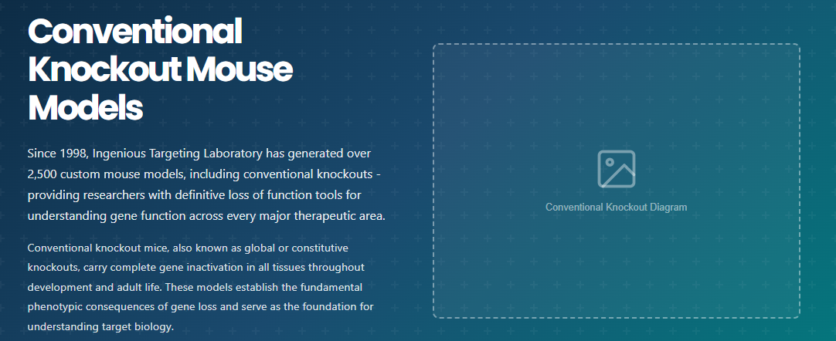

- These aren’t exactly the publications from the final google doc. Please update to what’s on the final doc:


